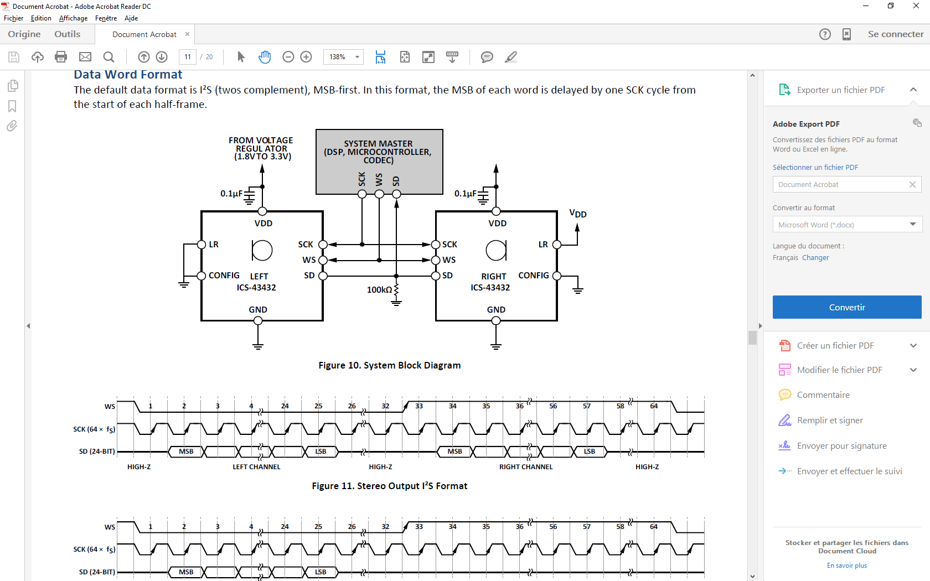

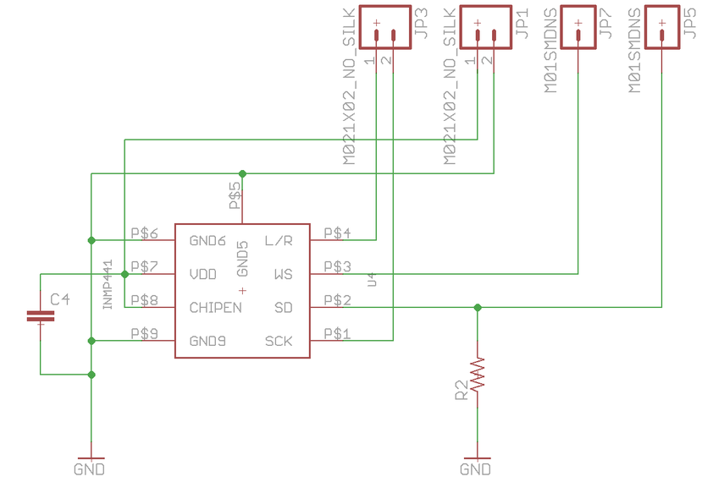

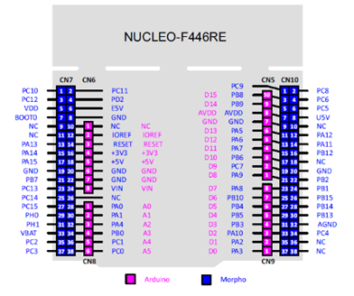

|  |  |  |  |  |  |  |
| --- | --- | --- | --- | --- | --- | --- |
| I2S | Mic Wire | Signal | 446RE | I2S1 446RE | Arduino | Morpho |
| SD | yellow | Data | PA7 | I2S1_SD | CN5-4 | CN10-15 |
| CLK | green | Clock | PA5 | I2S1_CK | CN5-6 | CN10-11 |
| WS | blue | Chip select | PA4 | I2S1_WS | CN8-3 | CN7-32 |
| 3v3=VDD | brown | Power |  |  | CN6-4 | CN7-16 |
| L/R | red | Left or Right | L=GND | R=VDD |  |  |
| GND | orange | Ground |  |  | CN6-6  CN6-7 | CN7-20  CN7-22 |

WIFI NUCLEO

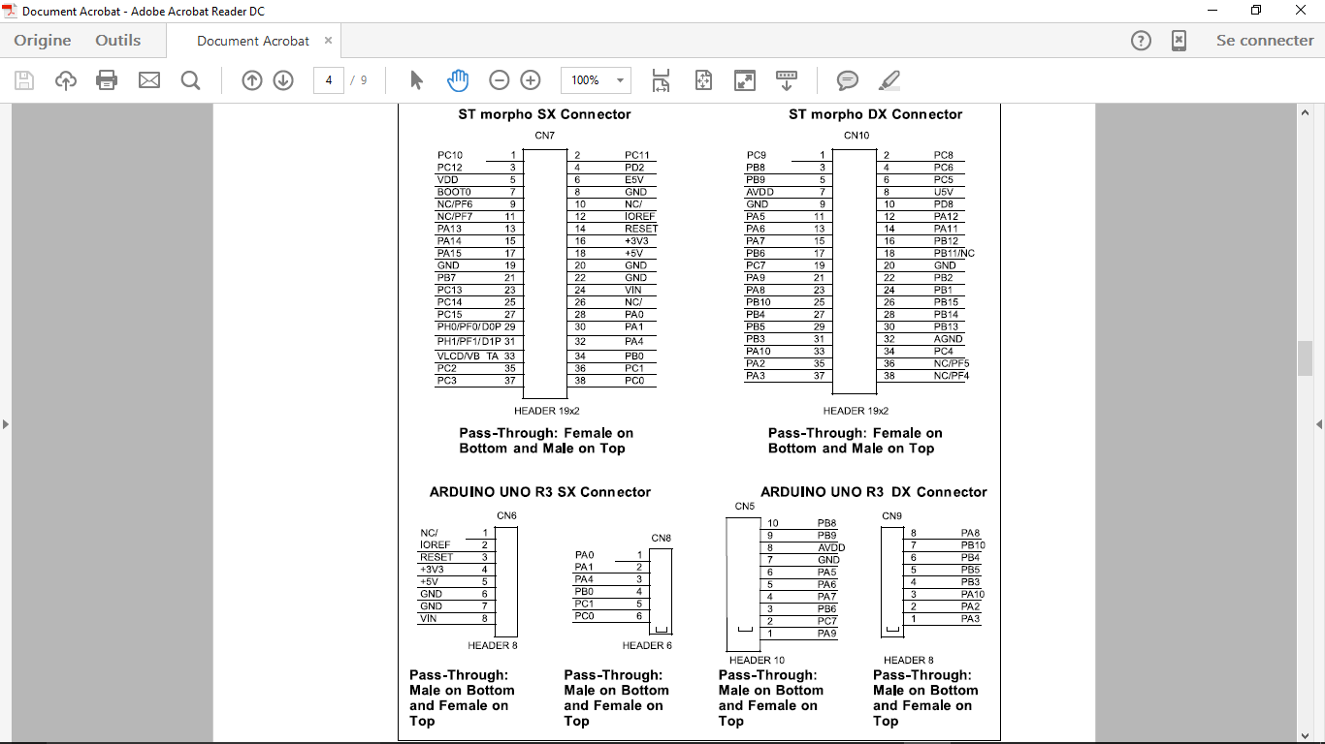

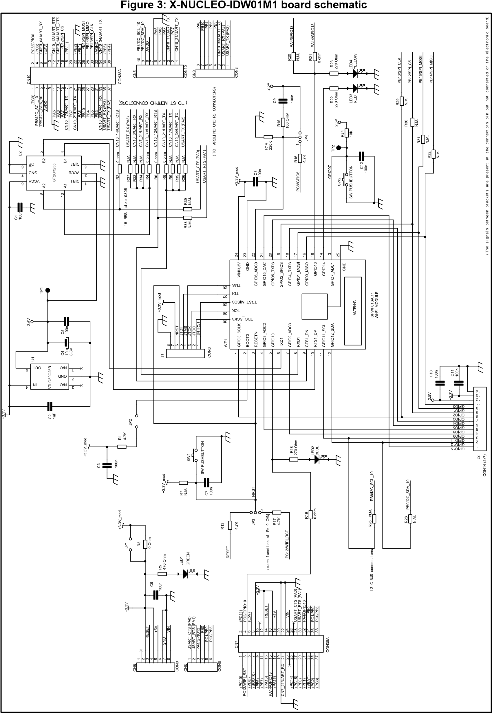

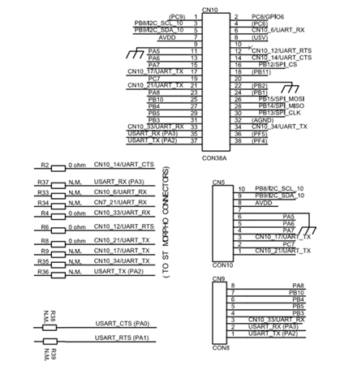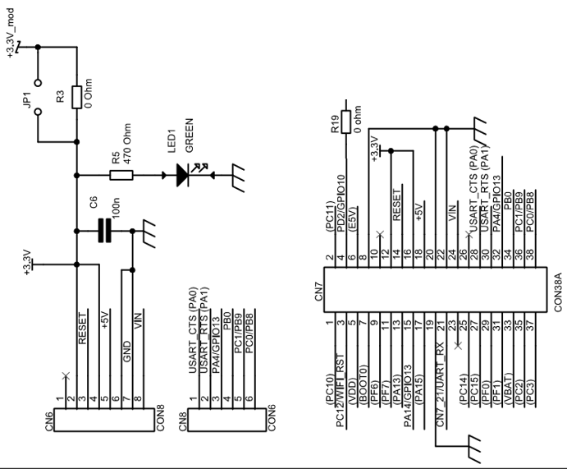

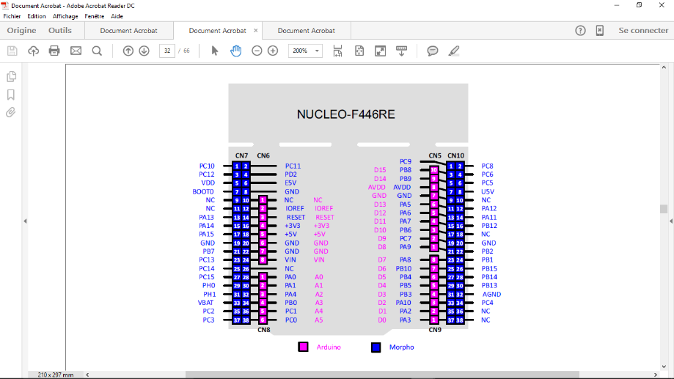

|  |  |  |  |
| --- | --- | --- | --- |
| 446RE | I2S1 446RE | Arduino | Morpho |
| PA7 | I2S1_SD | CN5-4 | CN10-15 |
| PA5 | I2S1_CK | CN5-6 | CN10-11 |
| PA4 | I2S1_WS | CN8-3 | CN7-32 |
| PC1 | I2S2_SD | CN8-5 | CN7-36 |
| PB10 | I2S2_CK | CN9-7 | CN10-25 |
| PB12 | I2S2_WS |  | CN10-16 |
| PB0 | I2S3_SD | CN8-4 | CN7-34 |
| PC10 | I2S3_CK |  | CN7-1 |
| PA15 | I2S3_WS |  | CN7-17 |